**Capstone Project - The Battle of Neighbourhoods**

This project the battle of neighbourhoods investigates the best neighbourhood to have access to pizza in New York City. We explored New York City.

**Introduction**

We look at the most desirable location to access pizza in New York City efficiently. The problem we aim to solve is which location should I stay to have greatest range of pizza venues in New York City.

**Data**

We have used FourSquare API to gather data about pizza venues in New York City.

**Methodology**

To determine this we are determining pizza venue density in New York City. FourSquare near query has been used to get the venues in the city. A centre coordinate has been calculated on the pizza venues to get the longitude and latitude values. Then the mean was calculated of the Euclidean distance from each pizza venue to the mean coordinates.

**Results**

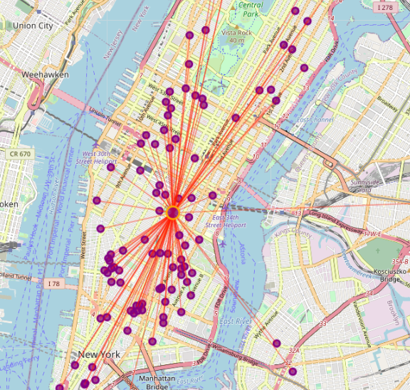

**Conclusion**

After considering the result it appears the neighbourhood around Madison Square Park is the best location for access to pizza venues.